

Semester Two

Examination 2017

Question/Answer booklet

MATHEMATICS
SPECIALIST UNITS 3 & 4

Section Two:
Calculator-assumed

Student Name: _____________________________________

Teacher’s Name: _____________________________________

Time allowed for this section
Reading time before commencing work: ten minutes
Working time for paper: one hundred minutes

Material required/recommended for this section

To be provided by the supervisor
This Question/Answer booklet
Formula Sheet (retained from Section One)

To be provided by the candidate
Standard items: pens (blue/black preferred), pencils (including coloured), sharpener, correction tape/fluid, erasers, ruler, highlighters

Special Items: drawing instruments, templates, notes on two unfolded sheets of A4 paper, and up to three calculators approved for use in the WACE examinations.

Important note to candidates
No other items may be taken into the examination room. It is your responsibility to ensure that you do not have any unauthorised notes or other items of a non-personal nature in the examination room. If you have any unauthorised material with you, hand it to the supervisor before reading any further.

Structure of this paper

 | Number of questions available | Number of questions to be attempted | Working time (minutes) | Marks available | Percentage of exam
Section One  Calculator—free | 8 | 8 | 50 | 50 | 35
Section Two  Calculator—assumed | 14 | 14 | 100 | 100 | 65
 |  |  |  |  | 100

Instructions to candidates

- The rules for the conduct of Western Australian external examinations are detailed in the
Year 12 Information Handbook 2017. Sitting this examination implies that you agree to abide by these rules.

- Answer the questions according to the following instructions.

Show all your working clearly. Your working should be in sufficient detail to allow your
answers to be checked readily and for marks to be awarded for reasoning. Incorrect answers given without supporting reasoning cannot be allocated any marks. For any question or part question worth more than two marks, valid working or justification is required to receive full marks. If you repeat an answer to any question, ensure that you cancel the answer you do not wish to have marked.

It is recommended that you do not use pencil, except in diagrams.

- You must be careful to confine your responses to the specific questions asked and to follow any instructions that are specific to a particular question.

- Spare pages are included at the end of this booklet. They can be used for planning your responses and/or as additional space if required to continue an answer.
- Planning: If you use the spare pages for planning, indicate this clearly at the top of the page.
- Continuing an answer: If you need to use the space to continue an answer, indicate in the original answer space where the answer is continued, i.e. give the page number. Fill in the number of the question that you are continuing to answer at the top of the page.

- The Formula Sheet is not handed in with your Question/Answer Booklet.

Section Two: Calculator–assumed 65% (100 marks)

This section has fourteen (14) questions. Attempt all questions. Write your answers in the spaces
provided.

Working time: 100 minutes

Question 9 (6 marks)

The functions f and g are defined as 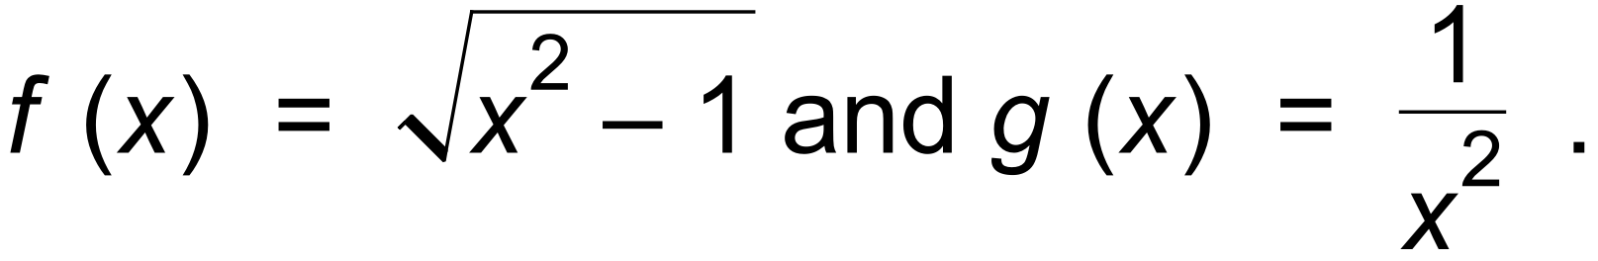

(a) Determine the expressions for:

(i) g o f (x). (1 mark)

(ii) g o g (x). (1 mark)

(b) For g o f (x) state:

(i) the domain. (2 marks)

(ii) the range. (1 mark)

(c) Given k (x) = x² + 4 and h o k (x) = | x |, determine the function h (x). (1 mark)

Question 10 (8 marks)

On the axes below sketch the locus of the complex number z = x + yi, given by:

(a) | z + 1 − 2i | ≤ 1 and | z + i | ≥ | z − (2 + i) | . (4 marks)
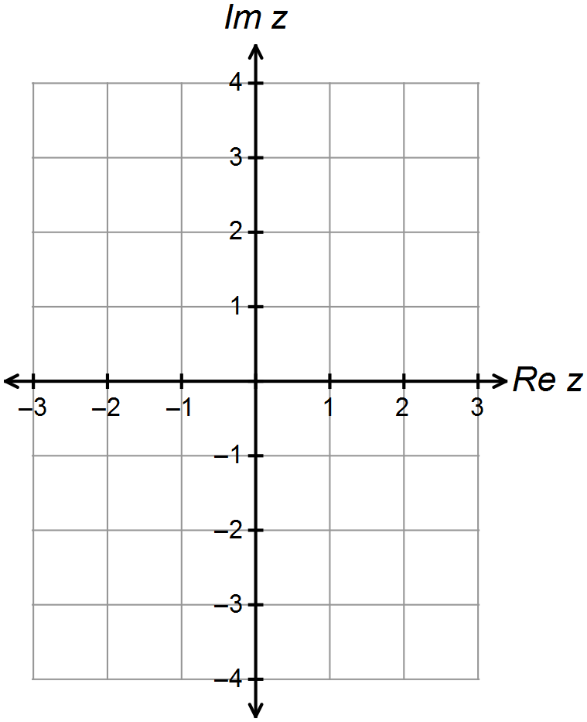



(b) 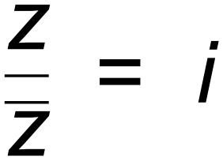 . (2 marks)

(c) Given that a = 1 + 2i and b = 3 + 4i, sketch on the complex plane below;
{ z : | z − a | + | z − b | = | a − b | }. (2 marks)

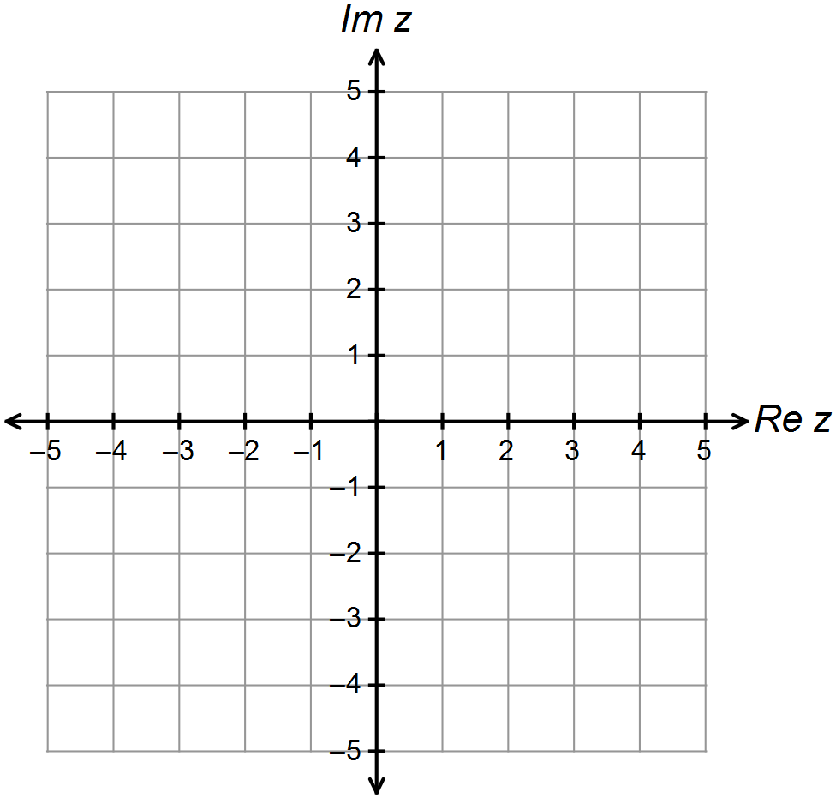

Question 11 (5 marks)

A section of the graph of the curve 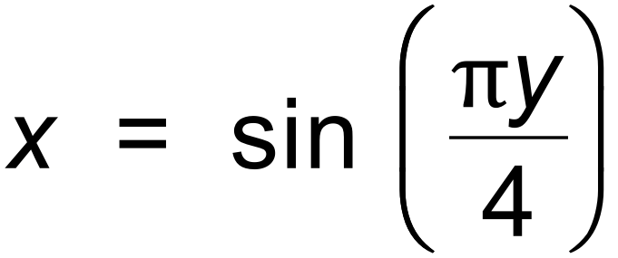 in the first quadrant is sketched below.
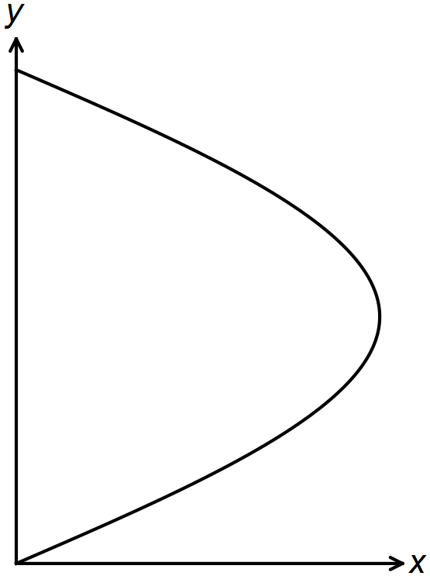

(a) Find an expression for 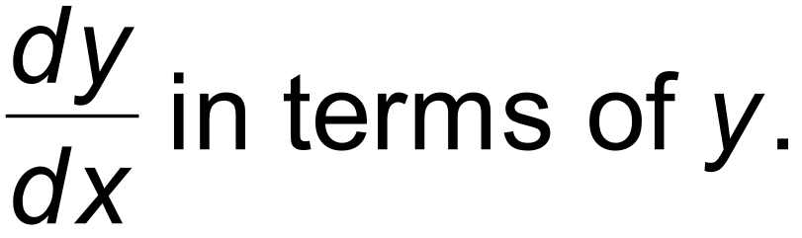 (2 marks)

(b) Determine the area of the region bounded by the curve 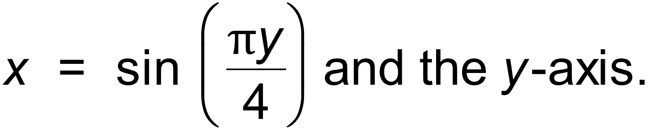
(ie. The loop above.) (3 marks)

Question 12 (6 marks)

A first order differential equation has a slope field as shown in the diagram below.
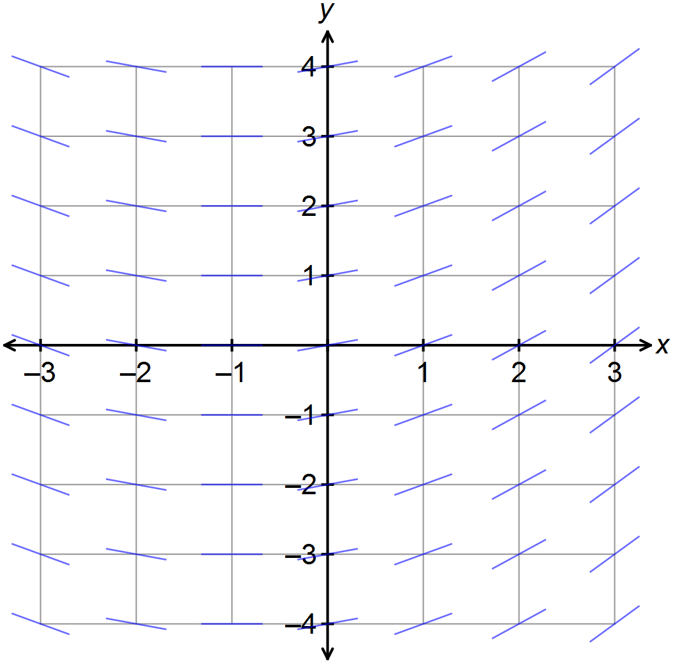

(a) Determine the general differential equation that would give this slope field. (3 marks)

(b) The slope field at point A (0, 1) has a value of 0.25.
Determine the equation for the curve y = f (x) containing A that is a solution to the differential
equation above. (3 marks)

Question 13 (5 marks)

The number of people, P, infected by a strain of influenza is modelled by
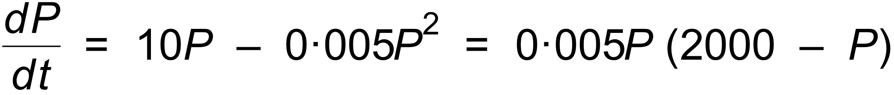 where t is the time in years after the outbreak.

There were 10 influenza cases initially observed.
The limiting size of the number of people infected is 2000.
The solution to the differential equation is given by the logistic curve:
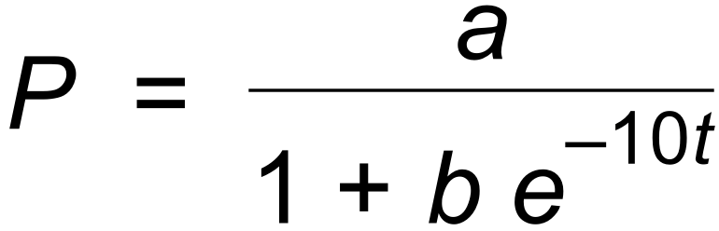 .

(a) State the values of a and b in the logistic equation. (2 marks)

(b) Find the time when the number of people infected is increasing at its greatest rate, and also
the population infected at this time. (3 marks)

Question 14 (8 marks)

The velocity v m/sec of a body moving in a straight line is given by 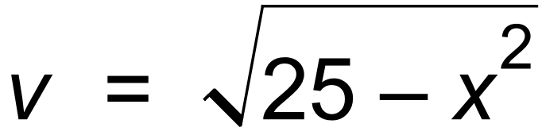 , where x cm is the displacement of the body from O, the origin.

(a) Show, using substitution and differentiation of the given curve, that:

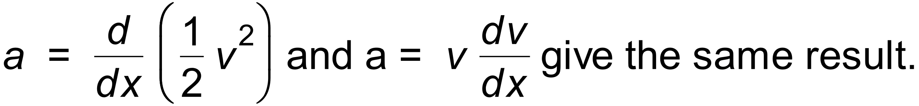 (2 marks)

(b) Find the velocity and acceleration of the body when it is 4 cm to the left of the origin O. (2 marks)

(c) Determine the exact value of x and a when v = 0. (2 marks)

(d) Calculate the exact velocity of the body when it has an acceleration of 2 cm/sec². (2 marks)
Question 15 (4 marks)

Consider the three simultaneous equations with a, b and c as constants.

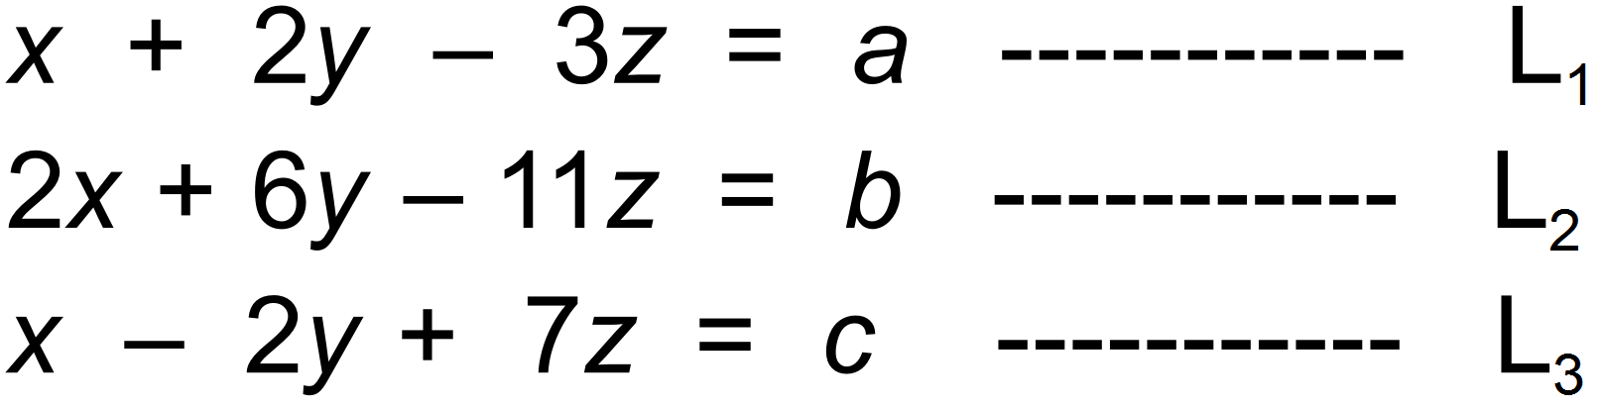

For what value(s) of a (if any) in terms of b and c does the above system have no solution?
(4 marks)

Question 16 (5 marks)

A particle in Simple Harmonic Motion travels from rest to rest, a distance of 30m in 5 seconds.

Find the particle’s:

(a) maximum speed. (3 marks)

(b) minimum acceleration and its displacement relative to the mean position at this instant. (2 marks)
Question 17 (6 marks)

(a) Sketch the graph of f (x) = | x + 1 | + | x − 1 | − 4. (1 mark)
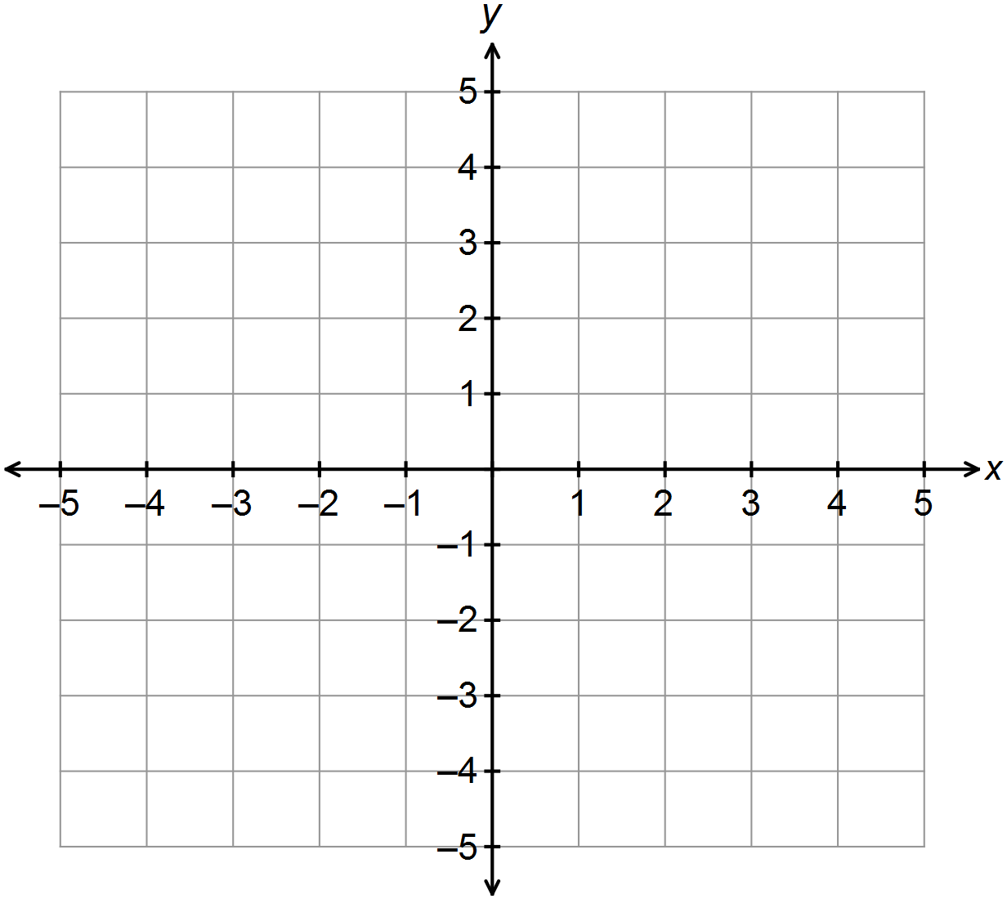

(b) The graph of h (x) = a | x + b | + a | x − b | − c is given below.
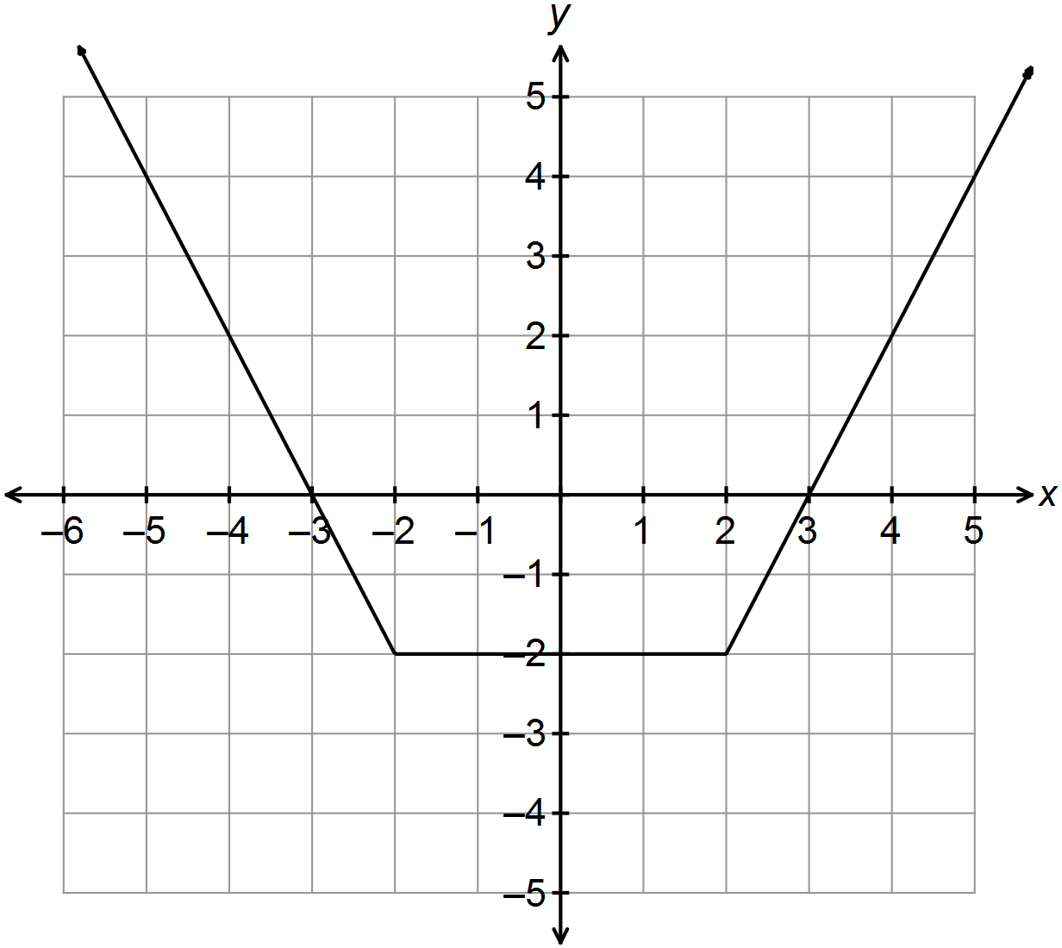 Determine the values of a, b and c. (3 marks)

(c) The graph of g (x) = 2x + d is such that h (x) = g (x) has only one solution.
Give the range of possible values for the constant d. (2 marks)

Question 18 (11 marks)

A 2 metre long watering trough for cattle is shown below. The trapezoidal face has height
1 metre and base width of 1 metre.
Initially the trough is full with water, but the cattle drink at a constant rate of 0.05 m³/hr.

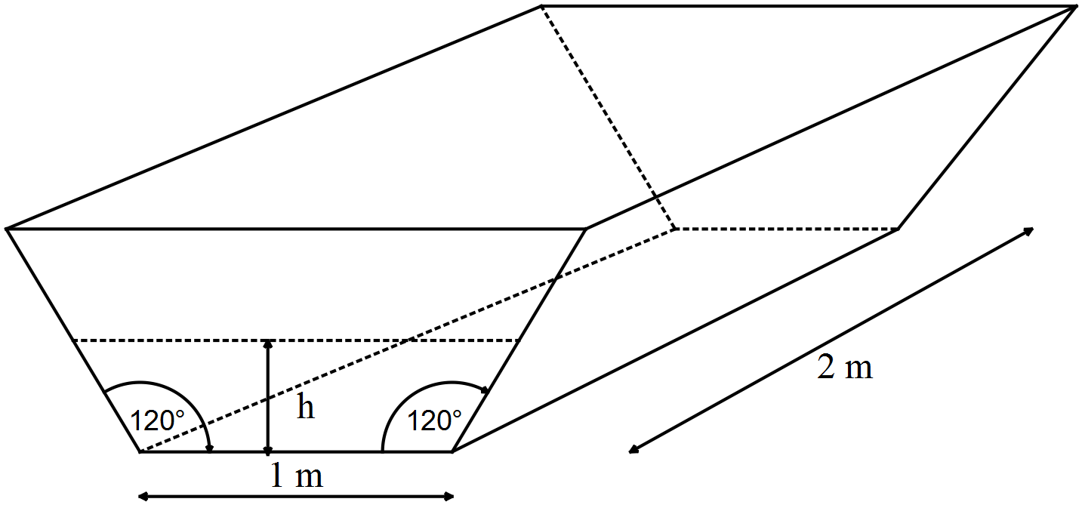

(a) Show that the volume of water in the trough, in m³, is given by:

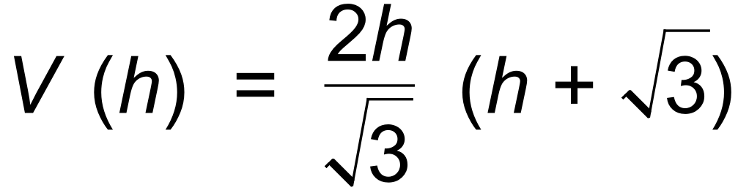 where h is the height of the water. (3 marks)

(b) Determine the rate of change of the depth correct to the nearest 0.001 m/hr when
the depth is 0.4 m. (3 marks)

(c) Show that the differential equation that relates 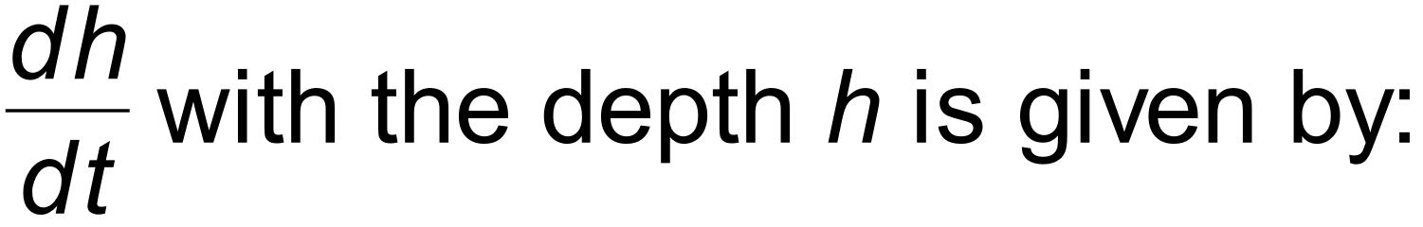 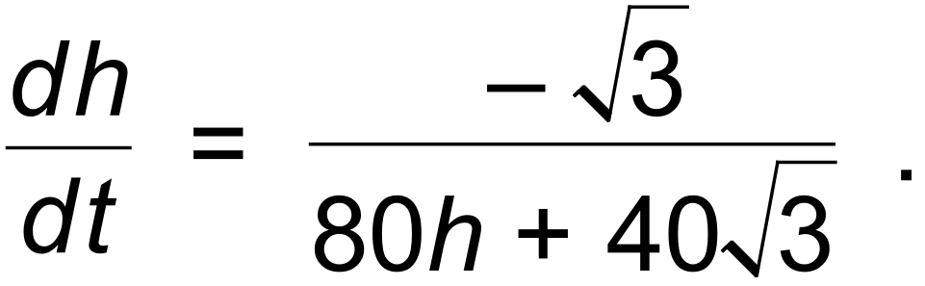 (2 marks)

(d) Hence, determine an expression for the time t in terms of h. (3 marks)

Question 19 (12 marks)

The mass of crayfish caught near the Abrolhos Islands is observed to be normally distributed with a mean of .

Joe the fisherman catches 65 crayfish.

(a) Determine the probability that:

(i) the mean crayfish mass will be less than 1.15 kg. (3 marks)

(ii) the total mass will be between 75 kg and 80 kg. (3 marks)

On another fishing trip, we are required to be 98% confident that the mean crayfish mass differs from the population mean by less than 0.05 kg.

(b) Find the number of crayfish that need to be caught. (2 marks)

A rival crayfisherman, Jamie, has started catching crayfish further out to sea than Joe. Jamie states that the crayfish caught are significantly bigger than in the area that Joe fishes in.

Over a month Jamie catches 220 crayfish with total mass of 270 kg. Assume 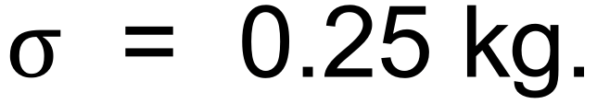

(c) Determine whether Jamie’s claim is supported at the 95% level of confidence. (4 marks)

Question 20 (9 marks)

A particle’s position vector, r (t) in metres, at any time t seconds is given by the equation:

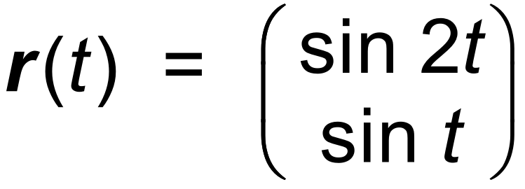

A plot of the path of the particle is shown below.
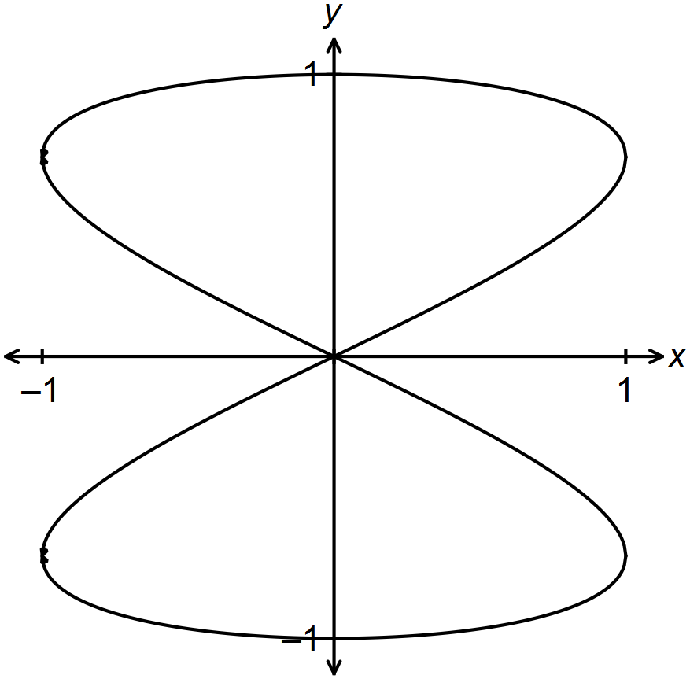

(a) Determine the Cartesian equation of the path in the form x² = f (y). (2 marks)

(b) Determine the speed of the particle when it reaches the point where x = −0.5 for
the second time. (4 marks)

(c) Use the formula 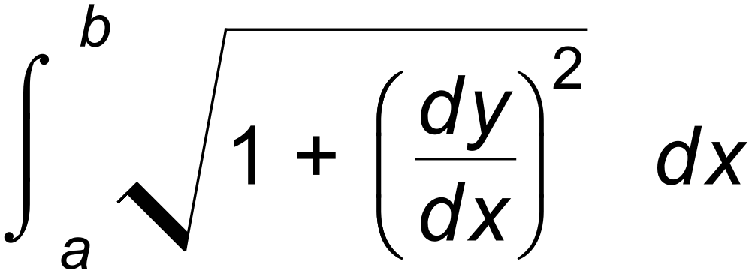 to find the distance travelled by the particle
in completing the whole course once. (3 marks)

Question 21 (10 marks)

Let A(1, 0, −3), B(3, −1, −1) and C(7, −3, 3) be three points.
Figure 1 shows the plane P₁ through B, with  as its normal.
The points D(3, 5, 2) and E(1, −3, 0) are on this plane.

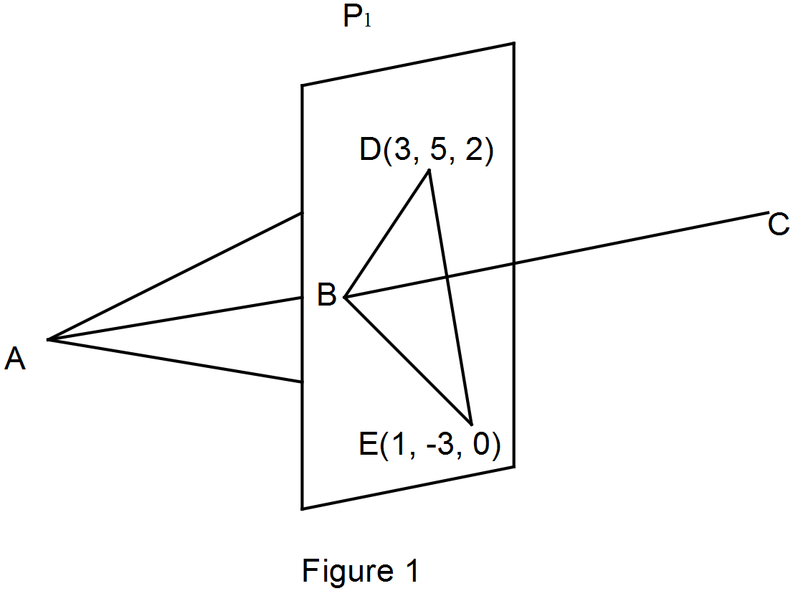

(a) If (2 marks)

(b) Find the vector equation of the plane P₁. (2 marks)

(c) Find the vector equation of the line through A and B. (1 mark)

Figure 2 shows that the lines AB, AD and AE continue on to meet the plane P₃, which is
parallel to P₁ and P₂.
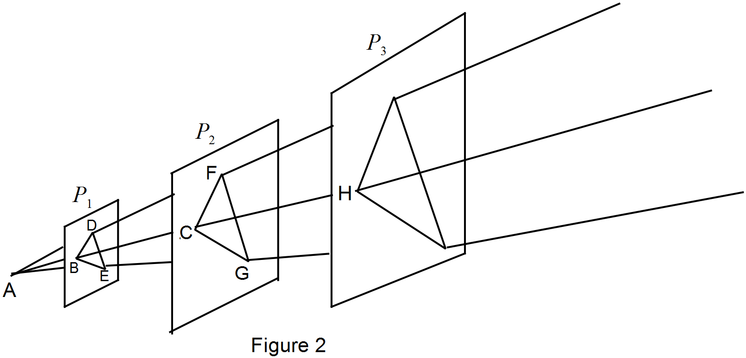

(d) Given that the area of ΔBDE = 9 units², find the area of ΔCFG. (2 marks)

(e) Given that the area of the triangle that is projected onto P₃ is 16 times the area of
ΔBDE, find the Cartesian equation of plane P₃. (3 marks)

Question 22 (5 marks)

A sphere is obtained by rotating a semi−circle with equation 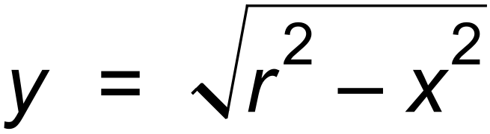 about the x−axis.
The sphere is sliced vertically at x = a and x = b, where −r ≤ a < b ≤ r.

(a) State the integral for the volume of the slice. (1 mark)

A spherical water melon has a diameter of 22 cm. A 2 cm slice is taken from the end of the melon.

(b) (i) Determine the volume of this slice. (2 marks)

(ii) Write the integral that would find the area, A, of the curved surface of this end slice, using the formula below. Do not evaluate the integral.

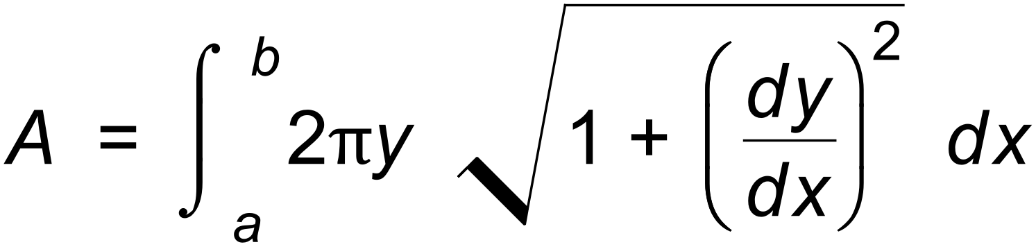 (2 marks)

End of questions
Additional working space

Question number(s): ……………………

Additional working space

Question number(s): ……………………

